**Objective**

To build a dashboard that will present monthly sales performance by product segment and product category to help client identifying the segments and categories that have met or exceeded their sales targets, as well as those that have not met their sales targets.

**Sheet View**

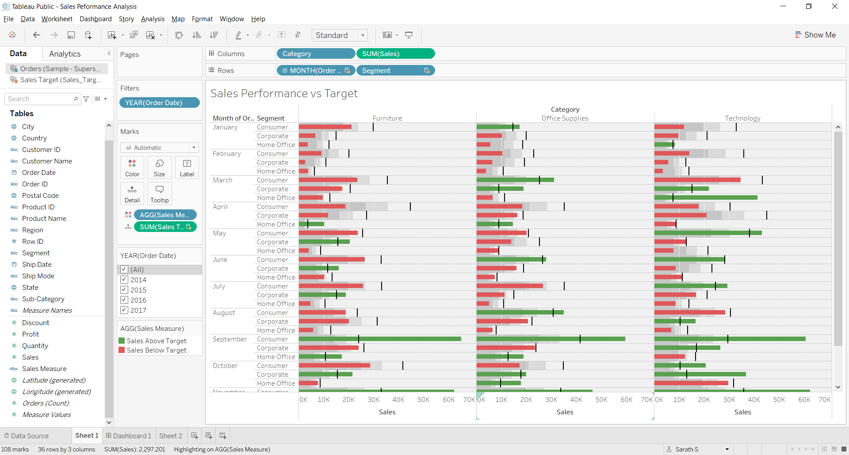

**Dashboard View**

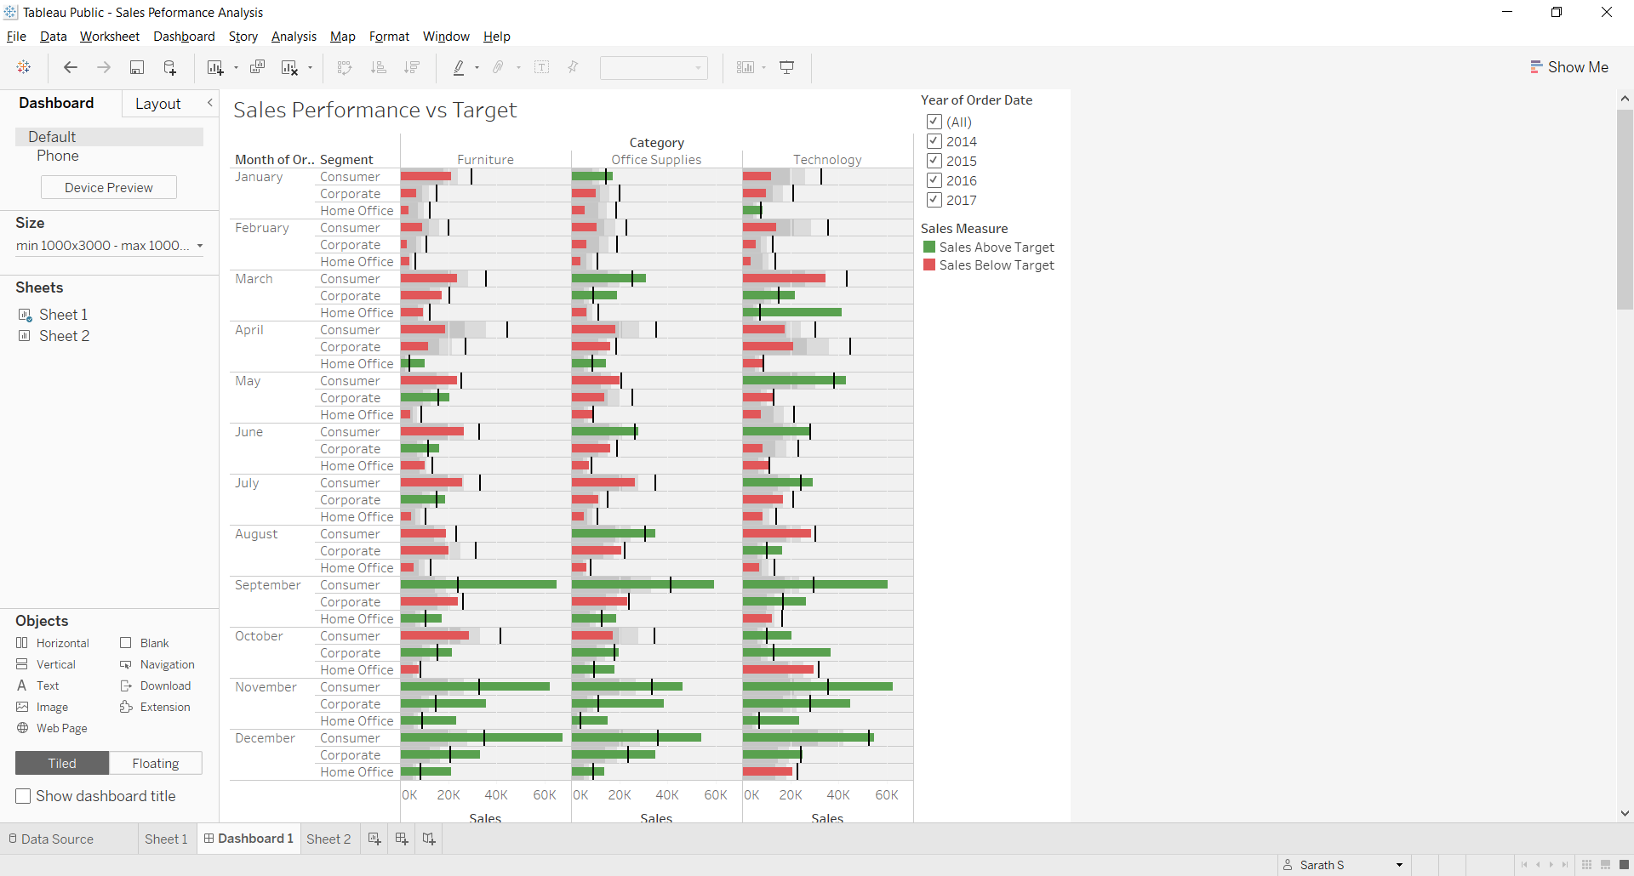

Saved in Tableau Public Sever as

[Sales Peformance Analysis | Tableau Public](https://public.tableau.com/app/profile/sarath.s5047/viz/SalesPeformanceAnalysis_16242960423030/Sheet1)